**Practical No: 03**

Large Sample test

## Example1:

Test the hypothesis H0: µ = 10 against H1: µ ≠ 10. A random sample of size 400 is drawn gives mean 10.2 and standard deviation 2.25. Use LOS = 5%

## Solution:

> n=400;mx=10.2;sd=2.25;m0=10

* zcal=(mx-m0)/(sd/sqrt(n))
* cat("z calculated is",zcal) z calculated is 1.777778
* pvalue=2*(1-pnorm(abs(zcal)))
* cat("p-value is",pvalue) p-value is 0.07544036> **Output:**

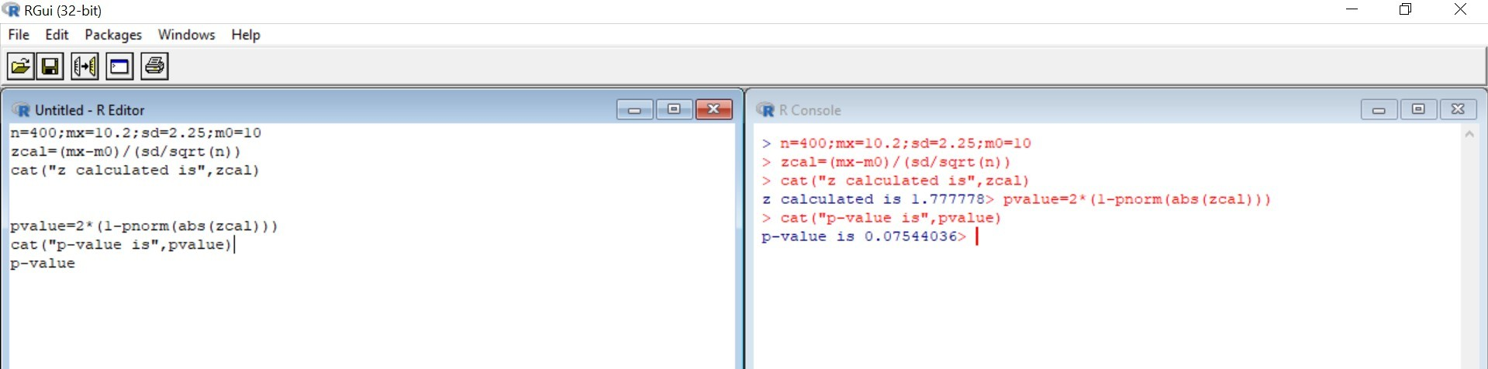

## Example 2:

Test the hypothesis H0: µ ≥ 50 against H1: µ &lt; 50. A random sample of size 65 is drawn gives mean 47.8 and standard deviation 10. Use LOS = 5%.

## Solution:

* zcal=(mx-m0)/(sd/sqrt(n))
* cat("z calculated is",zcal)

z calculated is -1.773697> pvalue=2*(1-pnorm(abs(zcal)))

* cat("p-value is",pvalue) p-value is 0.07611333>

## Example 3:

Two random samples of sizes 1000 and 2000 are drawn from two populations with same standard deviation 2.5 gives means 67.5 and 68 respectively. Test the hypothesis H0: µ1 = µ2 against

H1: µ1 ≠ µ2. Use 5% LOS.

## Solution:

n=1000;m=2000;mx=67.5;my=68;sx=2.5;sy=2.5

* zcal=(mx-my)/sqrt(sx^2/n+sy^2/m)
* cat("z calculated is",zcal)

z calculated is -5.163978> pvalue=2*(1-pnorm(abs(zcal)))

* cat("p-value is",pvalue) p-value is 2.417564e-07

p-value is approximately zero

Conclusion: Since p-value<LOS,therefore reject H0 at 5% LOS

**Output:**

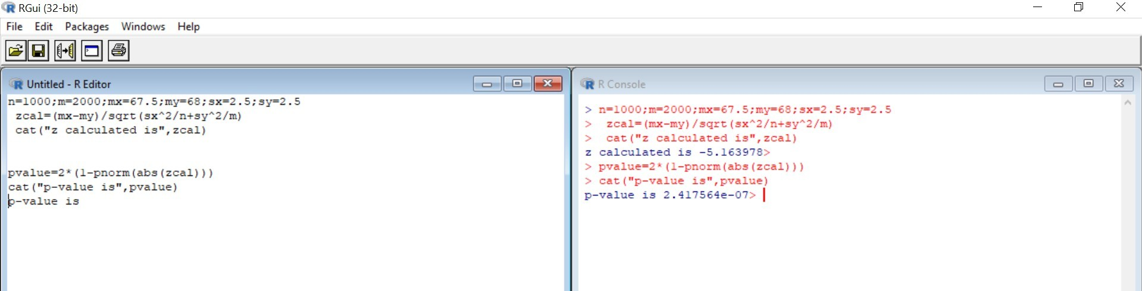

## Example 4:

A trucking firm suspects that that the average lifetime of 28,000 miles claimed for certain tyre is too high. To check this claim the firm puts 40 of these tyres on trucks and gets a mean lifetime of 27,563 miles and a standard deviation of 1,348 miles. What will the trucking firm conclude at 0.01 level of significance if it tests the null hypothesis µ = 28,000 miles against an appropriate alternative? Assume Normal distribution. Find ‘p’ value and interpret the value. H0: µ = 28000 against H1: µ &lt; 28000,

## Solution:

n=40;mx=27463;sd=1348;m0=28000

* zcal=(mx-m0)/(sd/sqrt(n))
* cat("z calculated is",zcal)

z calculated is -2.5195> pvalue=2*(1-pnorm(abs(zcal)))

* cat("p-value is",pvalue) p-value is 0.01175216> Reject H0

There is sufficient evidence to doubt the trucking firm’s claim

# Output:

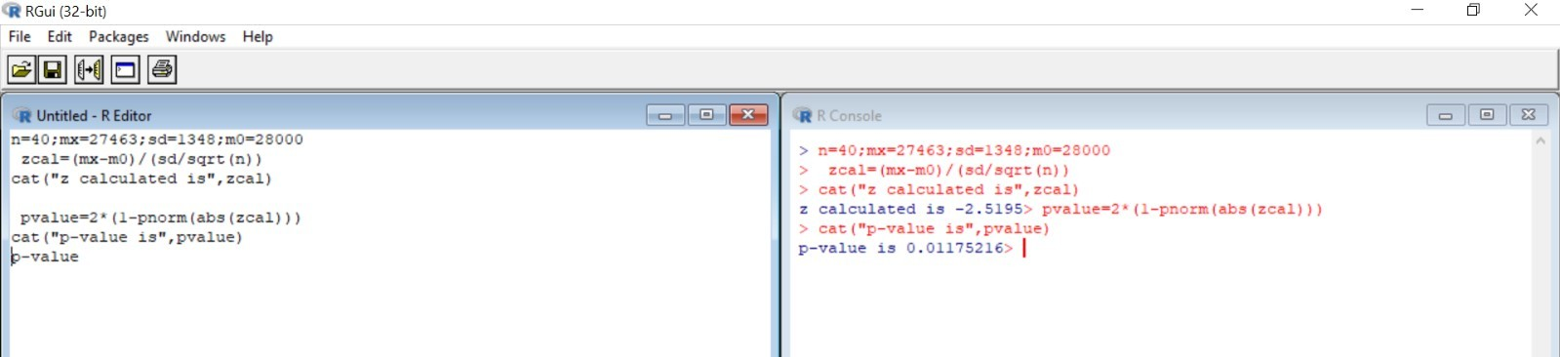

## Example 5:

Out of 1000 residents in a certain area 350 were found to be earthquake affected. Can we accept the claim that there are less than 30% earthquake affected residents? Use 5% L.O.S.

## Solution:

* n=1000;p=0.35;P=0.30
* zcal=(p-P)/sqrt(P*(1-P)/n)
* cat("z calculated is",zcal)

z calculated is 3.450328> pvalue=2*(1-pnorm(abs(zcal)))

* cat("p-value is",pvalue) p-value is 0.0005599062

5% L.O.S ie 0.05

Since p-value<LOS, therefore reject H0 at 5% L.O.S.

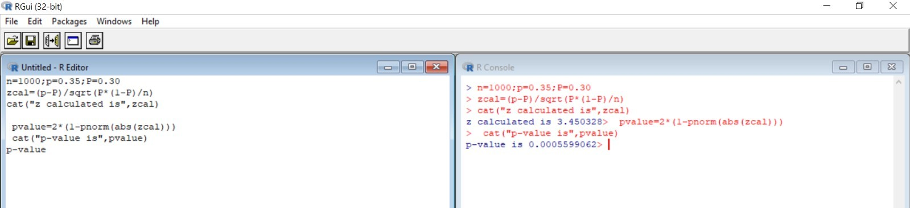

## Example 6:

From each of two consignments of apples, a sample of size 200 is drawn, and number of rotten apples counted. Test whether the proportion of rotten apples in the two consignments are significantly different?

|  |  |  |
| --- | --- | --- |
|  | Sample Size | No. of rotten apples |
| Consignment A | 200 | 44 |
| Consignment B | 200 | 30 |

N1=200, p1=44/200, n2=200, p2=30/200, alpha=0.05

H0:P1 = P2 against H1: P1 ≠ P2

**Solution:**

* n=200;p1=44/200;m=200;p2=30/200
* p=((n*p1)+(m+p2))/(n+m)
* q=1-p
* se=sqrt(p*q*(1/n+1/m))
* zcal=(p1-p2)/se
* cat("z calculated is",zcal) z calculated is 1.435411
* pvalue=2*(1-pnorm(abs(zcal)))
* cat("p-value is",pvalue) p-value is 0.15117

Since p-value>LOS, therefore do not reject H0 at 5% LOS

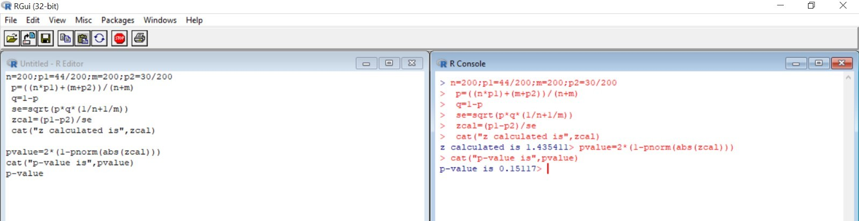

## Example 7:

In a battery factory, 8% of all batteries made are assumed to be defective. Technical trouble with production line, however, has raised concern percent defective has increased in past few weeks. Of n = 600 batteries chosen at random, 70 600 ths 70 600 ≈ 0.117 of them are found to be defective. Does data support concern about defective batteries at α = 0.05

## Solution:

n=600;o=0.117;mean=0.08

* zcal=(o-mean)/sqrt((mean*(1-mean))/n)
* cat("z calculated is",zcal)

z calculated is 3.340707> pvalue=2*(1-pnorm(abs(zcal)))

* cat("p-value is",pvalue) p-value is 0.0008356523 Since p-value> LOS Reject H0 at 5% LOS **Output:**

